Pipestone County Commissioner Meeting
August 22, 2017
The Pipestone County Commissioners met with Chairman Les Nath, Commissioners Chris Hollingsworth, Luke Johnson, Bruce Kooiman, and Dan Wildermuth. County Administrator Sharon Hanson was also present. Chairman Nath called the meeting to order at 9:00 AM with the Pledge of Allegiance to the Flag.
AGENDA
Motion by Kooiman, seconded by Wildermuth to approve the agenda. Motion carried unanimously.
CONSENT AGENDA
Motion by Johnson, seconded by Hollingsworth to approve the consent agenda as follows:
1. Approve Minutes of August 8, 2017
2. Hospital Warrants in the amount of $319,618.15
3. Cattle Barn Donations
a. First Bank and Trust - $10,000.00
b. Jer’s Electric Inc. - $5,000.00
Motion carried unanimously.
BRANDI SCHAAP / CAROL SCOTTING FAIR FOLLOW-UP
County 4-H Program Coordinator Brandi Schaap reviewed information on the 2017 Pipestone County Fair. Schaap announced that Extension Administrative Support Specialist Carol Scotting and her husband George Scotting were the recipients of this year’s 4-H Hall of Fame award. Commissioners congratulated Carol Scotting on her achievement and thanked her for her service and dedication over the years.
2018 BUDGET PRESENTATIONS/REVIEW
Southwest Crisis Center Executive Director Sara Wahl presented information on the Southwest Crisis Center.
Treasurer Steve Weets reviewed the 2018 Treasurer and Data Processing Budgets.
Auditor Tyler Reisch reviewed the 2018 Auditor, Independent Audit, and Elections Budgets.
County Administrator Sharon Hanson stated that Treasurer Steve Weets has notified the County he will not seek another term as Treasurer. Therefore, the Personnel Committee would like to bring to the Board for consideration on September 5, 2017 the option of combining the offices of Auditor and Treasurer effective January 2019. This has been a statewide trend and currently 75 of 87 counties have a combined Auditor/Treasurer’s Office.
TERRY NELSON – WOODSTOCK TELEPHONE PROJECT
Woodstock Telephone Company General Manager Terry Nelson presented information on a hybrid fiber to tower/wireless broadband project that Woodstock Telephone Company is considering in Pipestone County. The project involves bringing fiber to internet towers throughout Pipestone County in underserved areas and making a wireless internet available from the towers to rural residents. Construction of the project depends on receiving available state grant funds to partially fund the project. Nelson requested a letter of support from the Commissioners to include with the grant application. Motion by Kooiman, seconded by Hollingsworth to give Woodstock Telephone Company their letter of support for the fiber to tower/wireless broadband project they plan to install in Pipestone county. Motion carried unanimously.
PIPESTONE COUNTY MUSEUM YEAR IN REVIEW AND FUNDING REQUEST
Pipestone County Museum Director Susan Hoskins joined the meeting to give a review of the past year and present the 2018 budget funding request.
TAX FORFEITED PROPERTY – OLD MOVIE THEATER
Auditor Tyler Reisch and Pipestone City Building Inspector Doug Fortune joined the meeting to discuss the former movie theater in the City of Pipestone that is currently tax forefeited. Fortune presented pictures and identified areas of concern with the condition of the building. He received a quote in the amount of $7,962.88 which would be a temporary fix to the building to remove the immediate hazards that exist in back of the building. Motion by Wildermuth, seconded by Hollingsworth to spend up to $10,000.00 in order to fix the hazards which need immediate attention in the back of the building. Yeas: Hollingsworth, Johnson, Nath, Wildermuth. Nay: Kooiman. Motion carried.
TAX ABATEMENT REQUESTS
Jeremy Whipple, of PBM Land Management joined the meeting to voice concerns on the availability of tax abatement forms at the City for new projects. Whipple stated that he began construction on a duplex and was not aware of the county Tax Abatement Home Initiative until after he had already begun construction on a duplex, which is prohibited in the policy. He asked for Board consideration on allowing him to apply for tax abatement on that property. Commissioners stated they would take it under advisement.
Jeremy Whipple stated that he has another duplex property that he has not started construction on at this time which he would like the board to consider for tax abatement. Motion by Wildermuth, seconded by Johnson to set a public hearing date of September 5, 2017 at 9:30 a.m. on the PBM Land Management proposed property tax abatement request pursuant to Minnesota Statute 469.1813 and 116J.993 through 116J.995 consisting of new home construction. Motion carried unanimously.
2018 RECORDER BUDGET
Recorder Mary Ann De Groot presented the 2018 Recorder’s Budget.
PRIORITIZED BRIDGE REPLACEMENT RESOLUTION 59-30-17
Engineer David Halbersma joined the meeting. Motion by Johnson, seconded by Hollingsworth to approve Amending the Prioritized Bridge Replacement List
Resolution 59-30-17 which identifies the following deficient bridges to be added to the list of high priority bridges to be replaced, rehabilitated, or removed as soon as possible when funds are available.

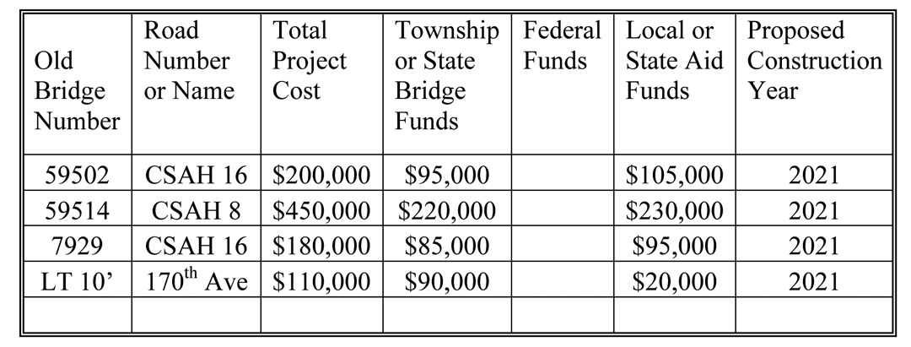

Motion carried unanimously.
LOCAL BRIDGE REPLACEMENT PROGRAM GRANT RESOLUTION 59-31-17
Motion by Hollingsworth, seconded by Kooiman to approve Resolution 59-31-17 that approves an agreement with the Minnesota Department of Transportation for the Fund Local Bridge Replacement Program Grant for Project SAP 059-597-002. The Resolution states that the amount of the grant has been determined to be $119,750.00 for project SAP 059-597-002. Motion carried unanimously.
DAVID FRANK - ARCASEARCH
David Frank of ArcaSearch gave a presentation on their product. ArcaSearch scans documents for the purpose of protection and preservation and makes them available digitally with search capabilities. Administrator Sharon Hanson would like the Board to consider contracting with ArcaSearch to scan Commissioner Minute books.
PRIME HEALTH TRUSTEE DELEGATION
PrimeWest Health has requested that each County which participates in their Prime Health County Employee Insurance pool, designate a trustee and an alternate trustee to represent their board. Motion by Kooiman, seconded by Johnson to appoint Commissioner Johnson as the Prime Health Trustee and Commissioner Hollingsworth as the alternate trustee. Motion carried unanimously.
Motion by Wildermuth, seconded by Hollingsworth to adjourn. Motion carried unanimously. Meeting adjourned at 11:32 a.m.
Les Nath ATTEST: Sharon Hanson
Pipestone County Board Chair County Administrator

